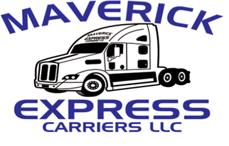

**2000 El Indio HWY**

**EAGLE PASS, TX 78852**

**MVR RELEASE AUTHORIZATION FORM**

**In conjunction with my potential employment at MAVERICK EXPRESS CARRIERS LLC. I x__________________________________________ consent to the release of my Motor Vehicle Records (MVR) to the company. I understand the company will use the records to evaluate my stability to fulfill driving duties that may be related to the position for which I am applying. I also consent to the review, evaluation, and other use of any MVR I may have provided to the company.**

**The consent given in satisfaction of Public Law 18 USC 2721 Section “Federal Drivers Privacy Protection Act”, and is intended to constitute “written consent” as required by this Act.**

**Signature (Applicant) x_________________________________________________________**

**Date: x______________________________**

**Drivers’ License Number x________________________________ State: x_______________**